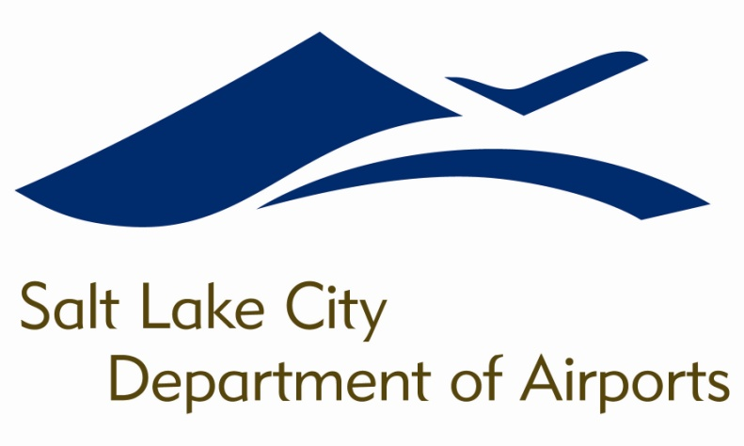

SALT LAKE CITY DEPARTMENT OF AIRPORTS
BOARD MEETING AGENDA

20 June 2018
8:00 A.M.

CONSENT AGENDA

Minutes of the 16 May 2018 Meeting

DISCUSSION ITEMS

Director’s Report – Bill Wyatt, Executive Director, SLCDA
- Airport Redevelopment Program (ARP) Update – Mike Williams, ARP Director, SLCDA

INFORMATION ITEMS

A. Financial Report – April 2018

B. Air Traffic Statistics – April 2018

C. Comparison of On-Time Operations – March 2018

D. Construction Report – June 2018

E. Media Clippings – June 2018

The next meeting will be held on Wednesday, August 1, 2018, at 8:00 a.m. Meetings are held in the Board Room located on the third level of the short-term parking garage. People with disabilities may make requests for reasonable accommodations no later than 48 hours in advance in order to attend this Airport Board Meeting. Accommodations may include alternate formats, interpreters, and other auxiliary aids. This is an accessible facility. For questions or additional information, please contact LuJean Christensen at 801-575-2096.

