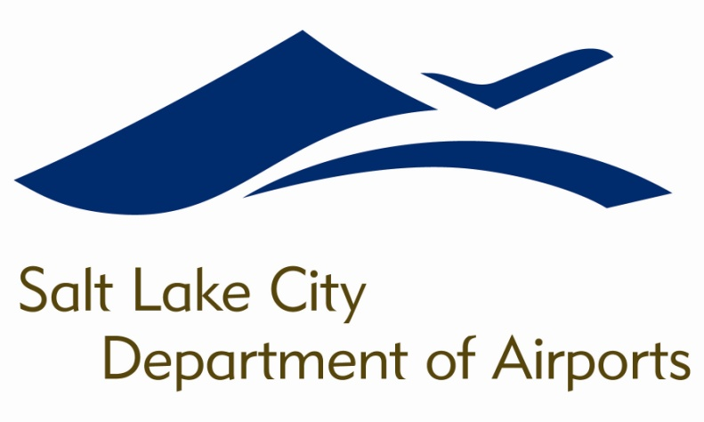

SALT LAKE CITY DEPARTMENT OF AIRPORTS
BOARD MEETING AGENDA

21 February 2018
8:00 A.M.

CONSENT AGENDA

Minutes of the 17 January 2018 Meeting

DISCUSSION ITEMS

Director’s Report – Bill Wyatt, Executive Director, SLCDA
- Airport Redevelopment Program (ARP) Update – Mike Williams, ARP Director, SLCDA
- Northwest Quadrant Update – Lara Fritts, Economic Development Director, SLC

INFORMATION ITEMS

A. Financial Report – December 2017

B. Air Traffic Statistics – December 2017

C. Comparison of On-Time Operations – November 2017

D. Construction Report – February 2018

E. Media Clippings – February 2018

The next meeting will be held on Wednesday, March 21, 2018, at 8:00 a.m. Meetings are held in the Board Room located on the third level of the short-term parking garage. People with disabilities may make requests for reasonable accommodations no later than 48 hours in advance in order to attend this Airport Board Meeting. Accommodations may include alternate formats, interpreters, and other auxiliary aids. This is an accessible facility. For questions or additional information, please contact LuJean Christensen at 801-575-2096.

