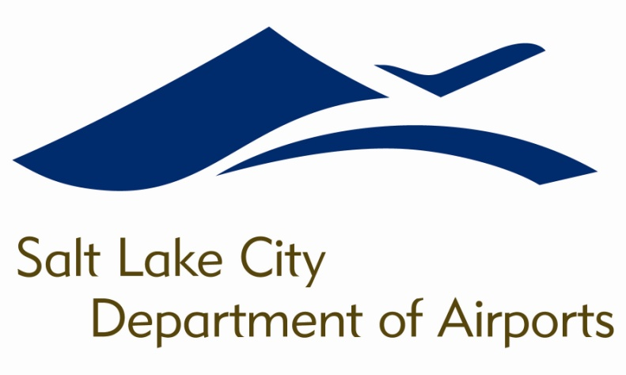

SALT LAKE CITY DEPARTMENT OF AIRPORTS
BOARD MEETING AGENDA

16 May 2018
8:00 A.M.

CONSENT AGENDA

Minutes of the 18 April 2018 Meeting

DISCUSSION ITEMS

Director’s Report – Bill Wyatt, Executive Director, SLCDA
- Airport Redevelopment Program (ARP) Update – Mike Williams, ARP Director, SLCDA
- Transportation Security Administration Overview – Mark Lewis, Federal Security Director for Utah, Transportation Security Administration
- South Valley Regional Airport, Public Hearing Regarding Land Sale for New Bingham Highway and 7800 South Street – Allen McCandless, Planning Director, SLCDA

INFORMATION ITEMS

A. Financial Report – March 2018

B. Air Traffic Statistics – March 2018

C. Comparison of On-Time Operations – February 2018

D. Construction Report – May 2018

E. Media Clippings – May 2018

The next meeting will be held on Wednesday, June 20, 2018, at 8:00 a.m. Meetings are held in the Board Room located on the third level of the short-term parking garage. People with disabilities may make requests for reasonable accommodations no later than 48 hours in advance in order to attend this Airport Board Meeting. Accommodations may include alternate formats, interpreters, and other auxiliary aids. This is an accessible facility. For questions or additional information, please contact LuJean Christensen at 801-575-2096.

