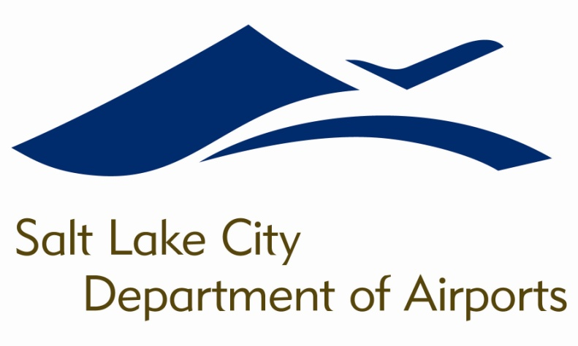

SALT LAKE CITY DEPARTMENT OF AIRPORTS
BOARD MEETING AGENDA

25 May 2016
8:00 A.M.

CONSENT AGENDA

Minutes of the 27 April 2016 Meeting

DISCUSSION ITEMS

Director’s Report – Maureen Riley, Executive Director, SLCDA
- Terminal Redevelopment Program (TRP) Update – Mike Williams, TRP Director, SLCDA
- North Concourse Program – Kevin Robins, Engineering Director, SLCDA

INFORMATION ITEMS

A. Financial Report – March 2016

B. Air Traffic Statistics – March 2016

C. Comparison of On-Time Operations – March 2016

D. Construction Report – April 2016

E. Media Clippings – May 2016

The next meeting will be held on Wednesday, June 15, 2016, at 8:00 a.m. Meetings are held in the Board Room located on the third level of the short-term parking garage. People with disabilities may make requests for reasonable accommodations no later than 48 hours in advance in order to attend this Airport Board Meeting. Accommodations may include alternate formats, interpreters, and other auxiliary aids. This is an accessible facility. For questions or additional information, please contact LuJean Christensen at 801-575-2096.

