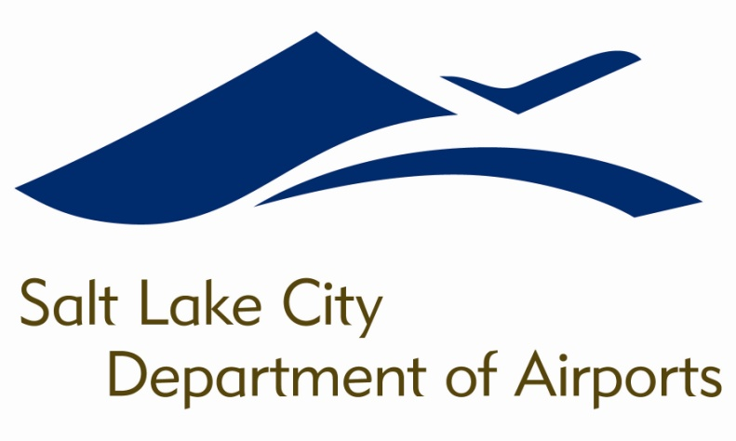

SALT LAKE CITY DEPARTMENT OF AIRPORTS
BOARD MEETING AGENDA

17 January 2018
8:00 A.M.

CONSENT AGENDA

Minutes of the 13 December 2017 Meeting

DISCUSSION ITEMS

Director’s Report – Bill Wyatt, Executive Director, SLCDA
- Airport Redevelopment Program (ARP) Update – Mike Williams, ARP Director, SLCDA
- Year-End Financial Audit – Ryan Tesch, Director of Finance, SLCDA
- Election of Board Chair and Vice-Chair

INFORMATION ITEMS

A. Financial Report – November 2017

B. Air Traffic Statistics – November 2017

C. Comparison of On-Time Operations – October 2017

D. Construction Report – January 2018

E. Media Clippings – January 2018

The next meeting will be held on Wednesday, February 21, 2018, at 8:00 a.m. Meetings are held in the Board Room located on the third level of the short-term parking garage. People with disabilities may make requests for reasonable accommodations no later than 48 hours in advance in order to attend this Airport Board Meeting. Accommodations may include alternate formats, interpreters, and other auxiliary aids. This is an accessible facility. For questions or additional information, please contact LuJean Christensen at 801-575-2096.

